Theoretical neuroscience: Exercise 5 Post-synaptic conductance
Date: 6/12/19

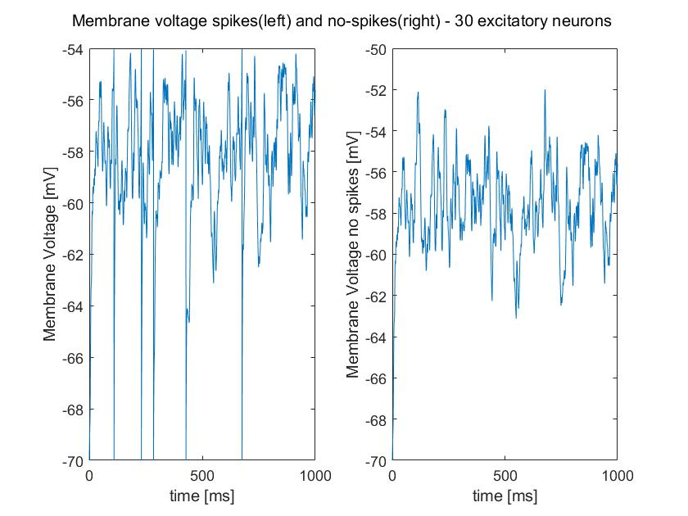

Figure 1: Membrane voltage spikes and no spikes (30* Excitation neurons at 20Hz and a relaxation constant of 1ms).

Above we can see the graphing of membrane voltage at the post-synapse, given the excitation input of 30 neurons. We will use the non-spiking membrane voltage in future analysis to measure against spike time variance.

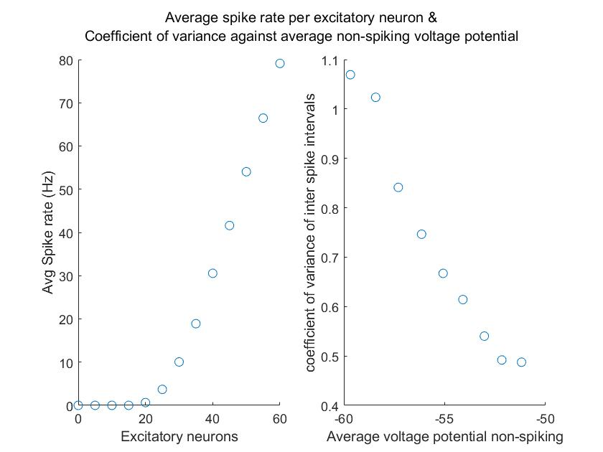

Figure 2: Average spike rate per excitatory neuron & Coefficient of variance against average non-spiking voltage potential.

If the average non-spiking voltage potential stays below the threshold potential, then it shows more random fluctuations and is irregular (Note: 1.06 coef. Of variance at 20 excitation neurons). We can see in figure 1 that as the average voltage potential (non-spiking) decreases below threshold, the coefficient of variance increases. Additionally, it can be observed in the left graph, that an increase in excitatory neurons will increase average spike rate (Hz).

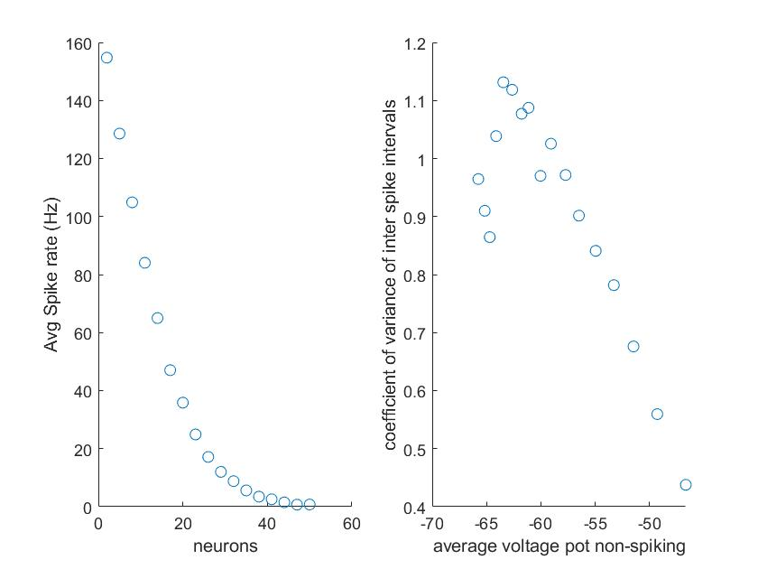

Figure 3: Average spike rate per reduction in inhibitory neuron (Excitatory neurons fixed 100) Coefficient of variance against average non-spiking voltage potential.

Figure 3 shows the changes in post-synaptic behaviour, with the input of 100 fixed excitatory neurons, while the number of inhibitory neurons changes (x axis). We can see as might be expected, that as we increase the number of inhibitory neurons, our average spike rate decreases (left). Similarly to Figure 2 (right), we see as the average voltage potential (non-spiking) decreases below threshold, the coefficient of variance increases. However there appears to be a peak in increases of coefficient of variance as it approaches more negative values – this appears to be the operating point. Our Matlab code gives these values as our operating point values:
m_cv = 1.1314
m_neuron_nums = 17
m_spike_rates = 47.0500
m_avg_non_spike_V = -63.4629

